**Project Design Phase-II**

**Technology Stack (Architecture & Stack)**

|  |  |
| --- | --- |
| Date | 26 October 2022 |
| Team ID | PNT2022TMID50747 |
| Project Name | Project – Smart Waste Management System for Metropolitan Cities |
| Maximum Marks | 4 Marks |

**Technical Architecture**

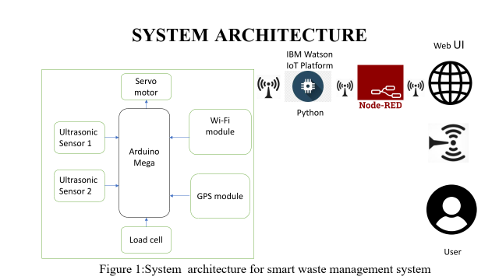

**Table-1 : Components & Technologies:**

|  |  |  |  |
| --- | --- | --- | --- |
| **S.No** | **Component** | **Description** | **Technology** |
|  | User Interface | Web Portal | Python, NodeRed |
|  | Application Logic-1 | To calculate the distance of dreck and show the real time level in web portal , information getting via ultra sonic sensor and the alert message activate with python script to web portal. | Ultrasonic Sensor / Embedded C |
|  | Application Logic-2 | To calculate the weight of the garbage and show the real time weight in web portal, this info getting via load cell and the alert message activate with python to web portal. | Load cell/ Embedded C |
|  | Application Logic-3 | Getting location of the Garbage. | GPS. |
|  | Cloud Database | Database Service on Cloud | IBM Watson IoT platform |
|  | File Storage | File storage requirements | GitHub, Local file  system |
|  | External API-1 | Firebase is a set of hosting services for any type of application. It offers NoSQL and real-time hosting of databases, content, social authentication, and notifications, or services, such as a real-time  communication server. | Firebase |
|  | Ultrasonic sensor | To throw alert message when garbage is getting full. | Distance Recognition Model. |
|  | Infrastructure (Server / Cloud) | Application Deployment on Local System / Cloud  Local Server Configuration: localhost  Cloud Server Configuration:localhost,Firebase. | Localhost, Web portal |

**Table-2: Application Characteristics:**

| **S.No** | **Characteristics** | **Description** | **Technology** |
| --- | --- | --- | --- |
|  | Open-Source Frameworks | Monitoring,Transportation,Removing wastage  which involves in guideline of recycling and  management. | Python |
|  | Security Implementations | The Data Security that allows to access the whole  information databases and resources. | Chrome |
|  | Scalable Architecture | It helps people to access easily in monitoring, cost  will be reduced, portable, keep environment clean  and hygiene. | Technology used |
|  | Availability | By exploring hardware and software helps to  manage the smarter bins everywhere. | RFID/IoT |
|  | Performance | The Smart Sensors use ultrasound technology to  measure the fill levels (along with other data) in  bins several times a day. The sensors send the  data to Sensor’s Smart Waste Management  Software System, a powerful cloud-based  platform, for data-driven daily operations, available  also as a waste management app. | GPRS/IoT |